PARTICIPANTS – SEPTEMBER 26 & 27

Organist: Sun: Contemporary Worship
Elder: Sat: Chris Schiller
Sun: David Hughes
Lector: Sun: Rhonda Fox
Acolyte: Sat: Bryce Jamison
Sun: Carolyn Fraher
Video Tech: Dustin Kaup
Audio Tech: Sun: Aaron Maas
Greeters: Sat: Don & Starla Ehrisman
Sun: Dick & Julie Senden, Dennis Rosenthal
Ushers: Sat: Dick, Chad, Brian & Matt Reppert
Sun: Daniel, Gary, Paul & Ryan Reppert

PARTICIPANTS –SATURDAY, OCTOBER 3

Guest Preacher: Rev. Chip Winter
Organist: Sat: Gwen Lindberg
Elder: Sat: D.J. Weddle
Acolyte: Sat: Taron Hasenkamp
Audio Tech: Sat. Mark Johnson
Greeters: Sat: Cecil & LaVonne Woodka
Ushers: Sat: Daniel, Gary, Paul & Ryan Reppert

SUNDAY, OCTOBER 4 – OKTOBERFEST

Worship Service: 10:30 am at the Nielsen Community Center

Guest Preacher: Rev. Chip Winter
Organist: Gwen Lindberg

Hearing Devices are available in the narthex. Please ask an usher for assistance.
Restroom facilities are in the mother’s room in the narthex, or downstairs.
Portals of Prayer are in the pew for you to take.

Elders at St. Paul Lutheran Church:
Larry Abrahams, 402-380-8928; Stan Giese, 402-372-2808; Chris Schiller, 402-380-3352; David Hughes, 402-372-5875; Mark Groth, 402-380-2775; D.J. Weddle, 402-372-9040

ST. PAUL LUTHERAN

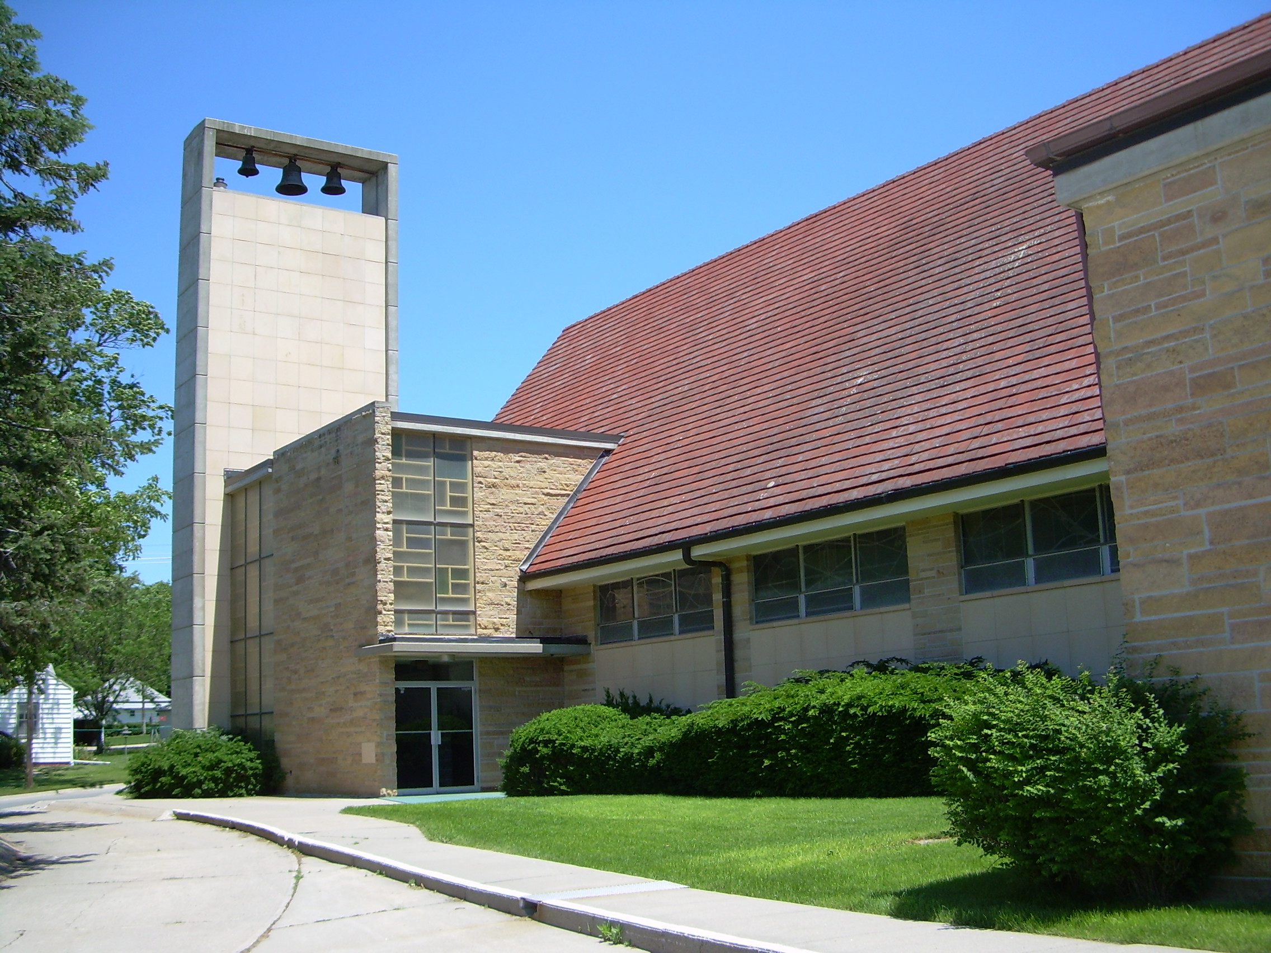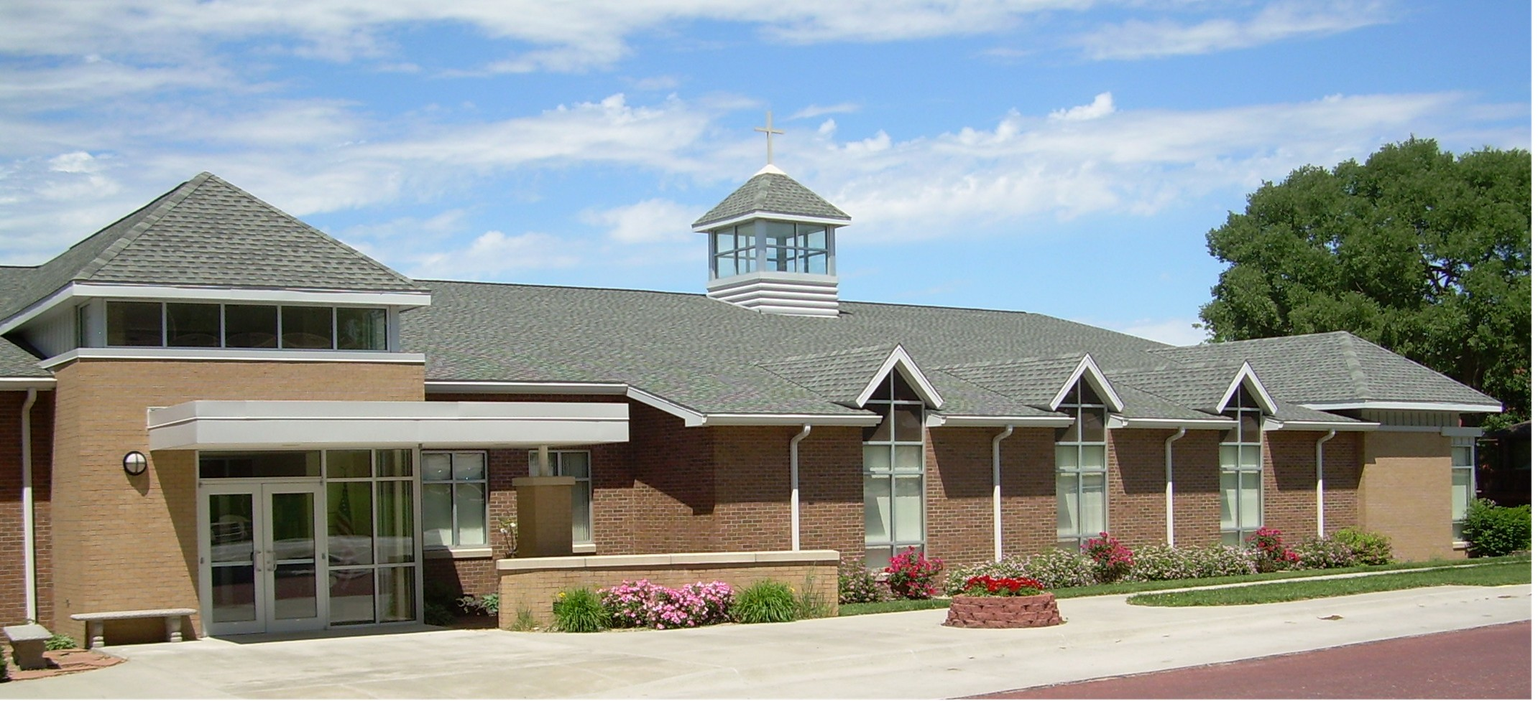
CHURCH AND SCHOOL
Rev. Richard Bringewatt, Pastor Kari Penrose, Administrator

CHURCH: 434 N. Lincoln, West Point, NE 68788 (402-372-2111) e-mail: stpaulwp@q.com
SCHOOL: 325 N. Colfax, West Point, NE 68788 (402-372-2355) e-mail: stpaulschool@stpaulwpne.org
PARSONAGE PHONE: 402-372-5321 web site: www.stpaulwp.org

“It is the mission of St. Paul Lutheran Church to reach the lost
with the saving Gospel of Jesus Christ,
and to equip the saved for a life of Christian service.”

WORSHIP SERVICES: SATURDAYS, 6:00 PM and SUNDAYS, 9:00 AM

Welcome! We are glad to have you with us this weekend, September 26 & 27, as we gather together to worship the Lord. Please sign the book of friendship, and if you are a visitor, please include your complete address. If you would like to be contacted or join our congregation, please include your phone number.

Please remember in your prayers this week:
* Diane Greckel, Andy Prusa, Gary Kepler, Daryl Boots, Ron Roland, David & Phyllis Doroh, Linda Schwinck, Cathy Meier, Dick Deutschman, Pearl Abrahams, Bob Fillmer, Joanne Mason, Dennis Carlson.

* Family of Bernice Miller on the death of her brother Delvin.

* The ministries of St. Paul Lutheran Church and School.

* Military personnel and their families including: Brittne Westerman, Janis Guenther,
Cole Wagner.
Call 372-2743 for our prayer chain

Reminder to cell phone users: unless you are on call for emergencies, please turn off all cell phones and electronic devices. Thank you.

